**Separation of monomer and dimer DNA Origami using SEC HPLC 4-5/16**

AFM images of origami monomer and origami dimers.

The size of the monomer is 90X60X2.5 nm.

The size of the dimer is 180X60X2.5 nm.

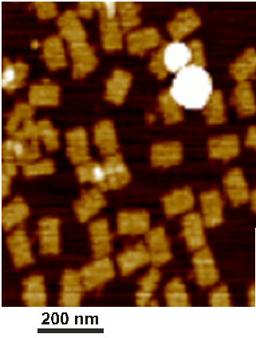

Monomer under AFM

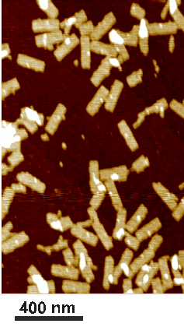

Dimer under AFM

Simulation shows that origami monomer in solution maybe bend to the following structure (diameter ~ 14 nM). Meaning the dimer will be a roughly tube of the length180 nm and diameter ~14 nm.

**– but that is not certain**

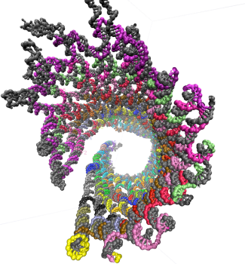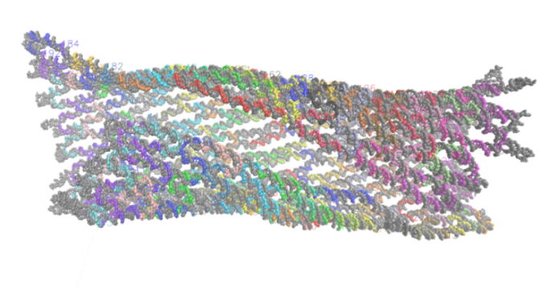

**Results:**

Sample preparation method:

* Add TEAA to 100uL in volume
* Pre-Assembly – 0.2uL TE
* ‘M13mp18 – 2uL TE
* Monomer – 10uL TAE 4mM Mg
* Dimer - 10uL TAE 250mM NaCl

**Pre Assembly** – **A mixture of 200 ssDNA at 32 & 24 bases long**. Kept in TE 1x (10mM Tris, 1mM EDTA)

**m13mp18** – **ssDNA 7,249 bases**, 700kDa, 80% of molecules are circular. Kept in TE 1x

**Origami monomer** – 60x90nm, 1400kDa. Kept in TAE 1x (40mM Tris, 20mM acetic acid, 1mM EDTA) 4mM Mg2+

**Origami Dimer** – 60x180nm, 2800k Kept in TAE 1x 250mM NaCl

**Protein KW-803 pore size 100nm – No Salt in the Running Buffer**

*Running Buffer: TEAA 1x (Triethylammonium acetate 0.1M) 0.5ml/min*

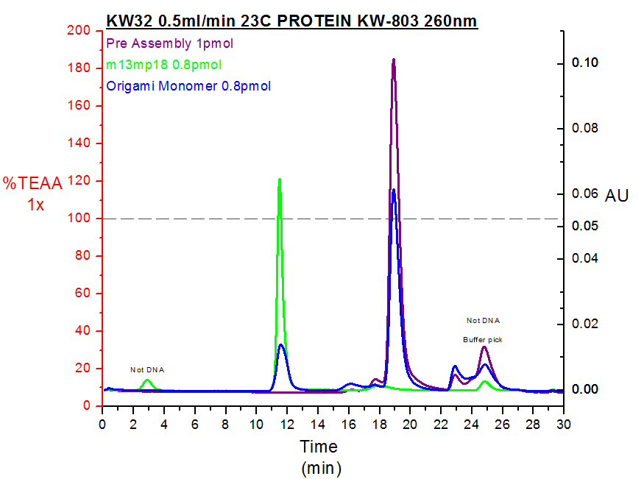

**Origami monomer**

**m13mp18**

**Protein KW-803 pore size 100nm – TEAA 1x 500 mM NaCl 0.5ml/min**

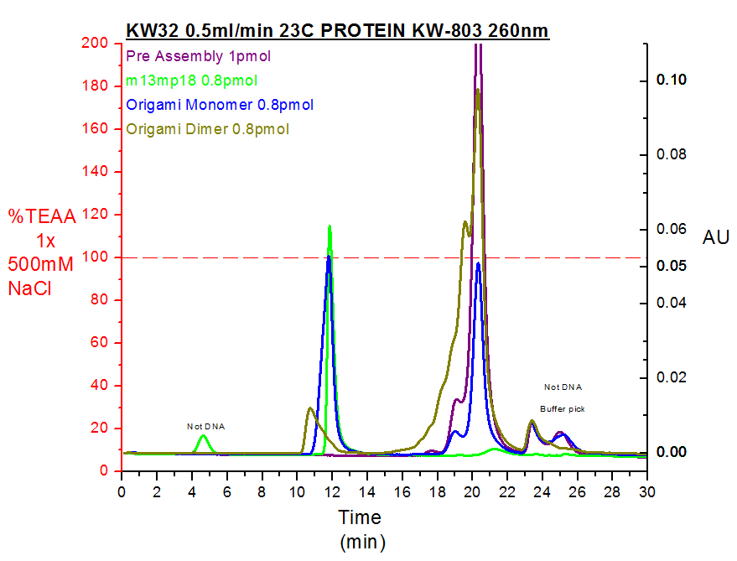

**Origami dimer**

**Origami monomer**

**m13mp18**

**Slower flow rate – 803 (with 500 mM NaCl)**

*Running Buffer: TEAA 1x 500mM NaCl 0.2ml/min*

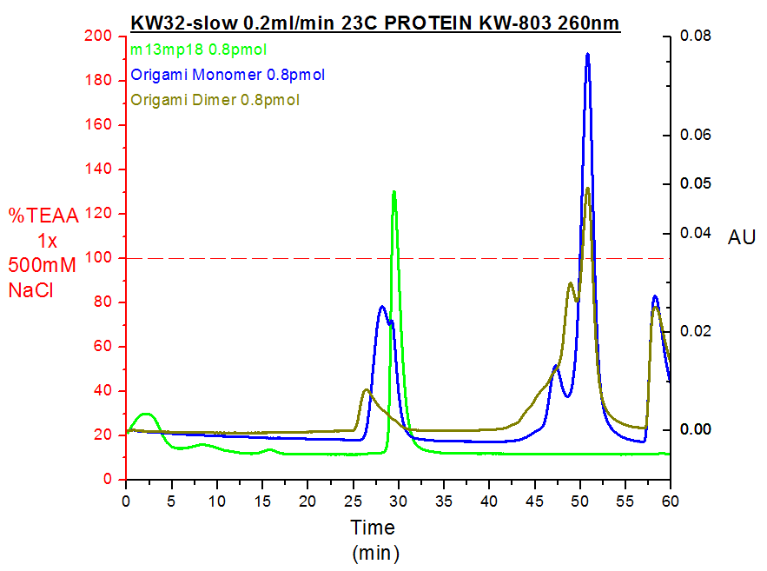

**m13mp18**

**Origami monomer**

**Origami dimer**

**Reinjection of Monomer**

*Running Buffer: TEAA 1x 0.5ml/min*

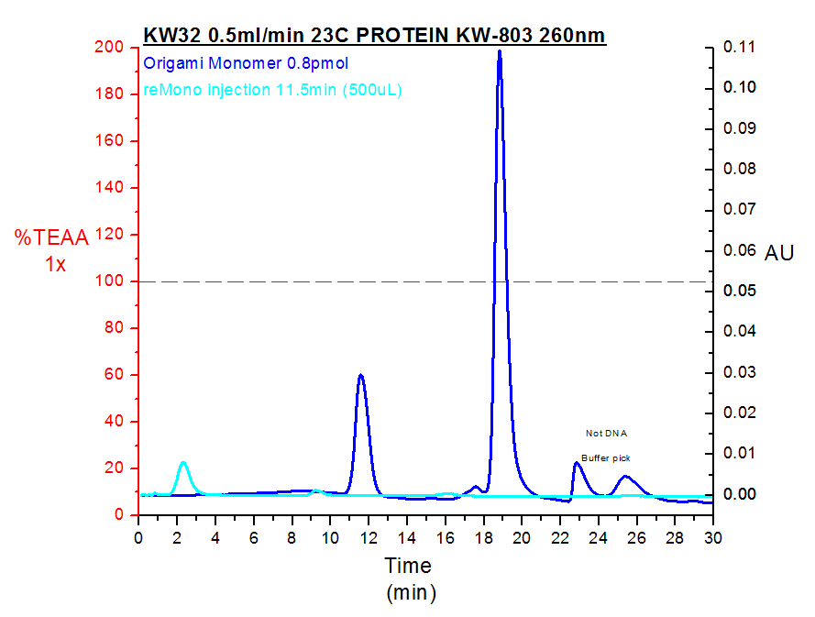

*Running Buffer: TEAA 1x* ***500mM NaCl*** *0.5ml/min*

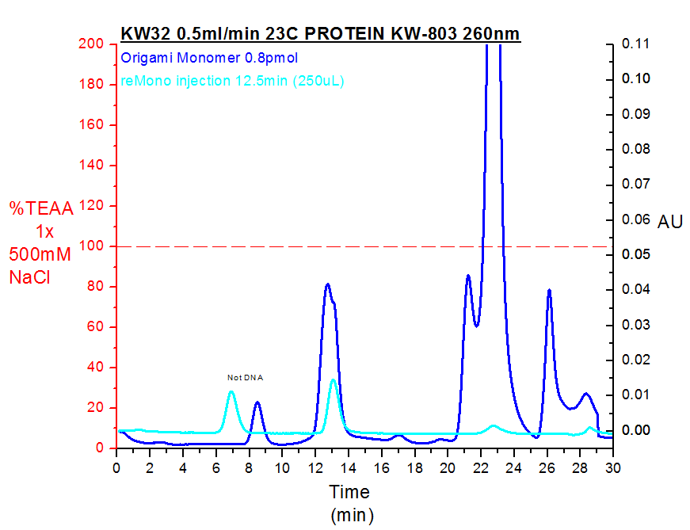

**KW-804, pore size 150nm, (with 500 mM NaCl)**

*Running Buffer: TEAA 1x 500mM NaCl 0.5ml/min*

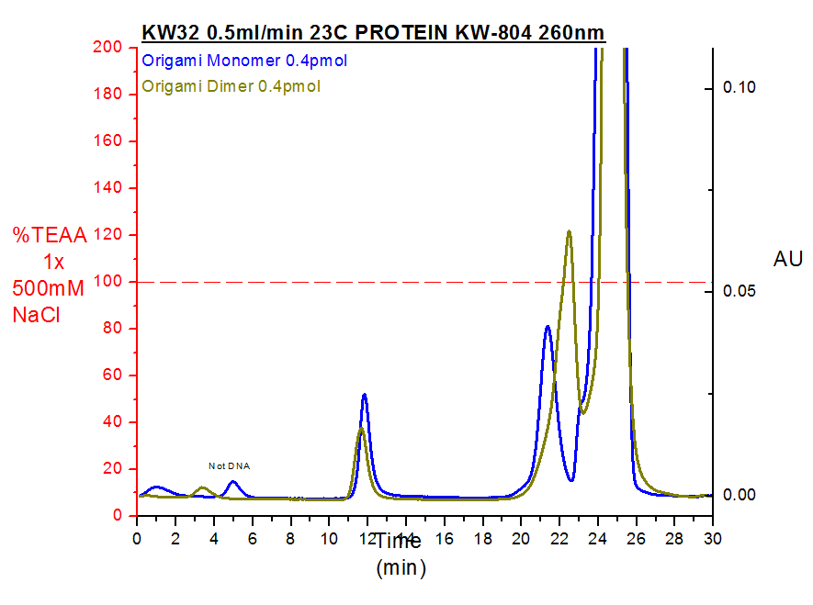

**Origami dimer**

**Origami monomer**

**Asahipak GS-520 HQ pore size 200 nm (ION EXCHANGE) – No Salt**

*Running Buffer: TEAA 1x 0.5ml/min*

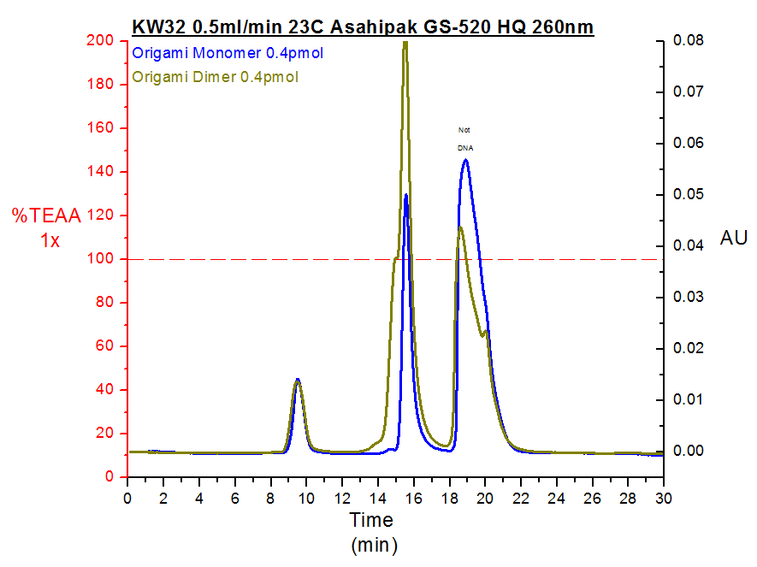

**Asahipak GS-520 HQ pore size 200 nm (ION EXCHANGE) – 500 Mm fixed**

*Running Buffer: TEAA 1x 500mM NaCl 0.5ml/min pH=7*

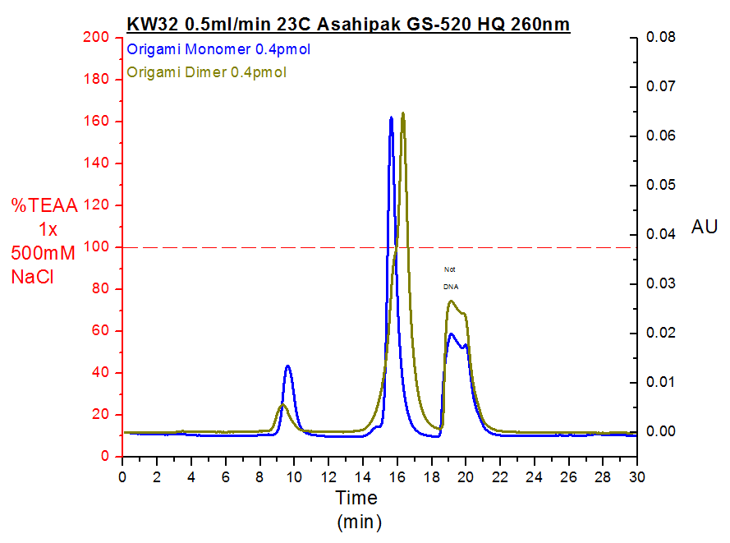

Different pH and salt measurements

*Running Buffer: TEAA 1x 0.5ml/min pH=5.5*

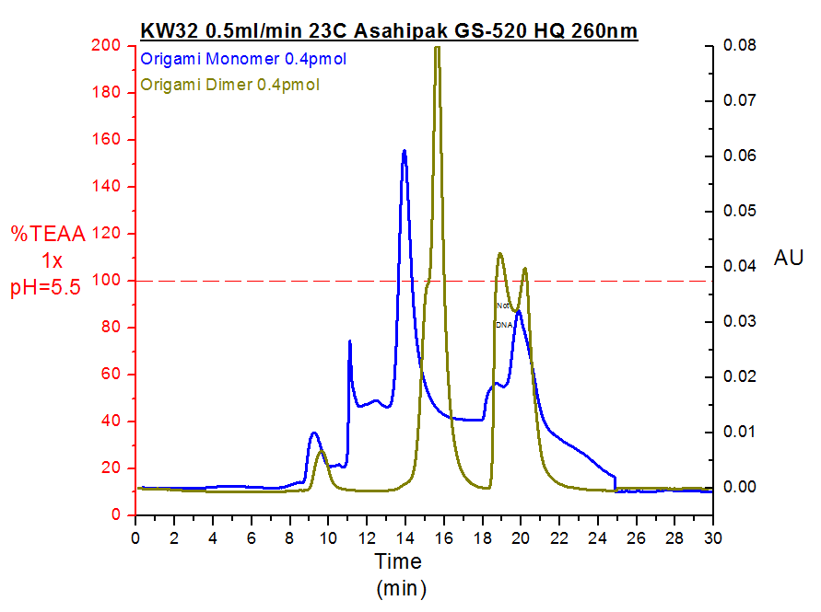

*Running Buffer: TEAA 1x 0.5ml/min pH=5.5 50mM NaCl*

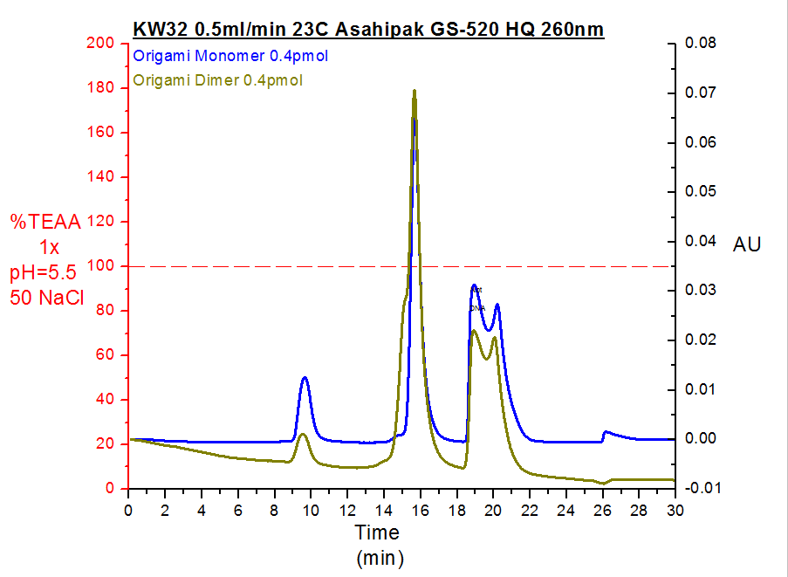

*Running Buffer: TEAA 1x 0.5ml/min pH=8.5*

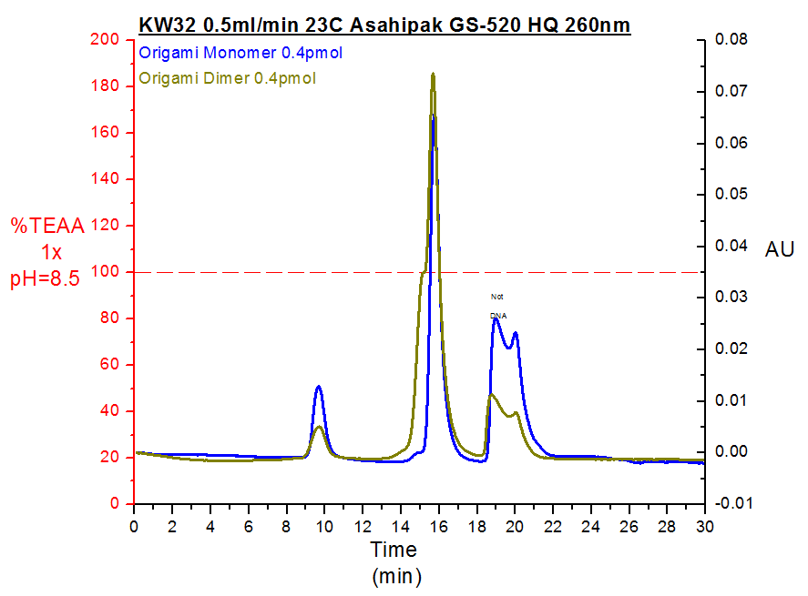

*Running Buffer: TEAA 1x 0.5ml/min pH=8.5 50mM NaCl*

